EXPERIMENT 13
DETECT WEB APPLICATION VULNERABILITIES USING SECURITY TOOLS

1. AIM
To perform comprehensive vulnerability scanning against web applications using OWASP ZAP and Nikto to categorize and report security risks.

2. THEORY
Automated VAPT tools crawl applications, test payload signatures, and evaluate response behaviors to generate structured security assessment reports.

3. TOOLS REQUIRED
- OWASP ZAP
- Nikto CLI
- Target Application (OWASP Juice Shop / DVWA)

4. PROCEDURE & COMMANDS
Step 1: Execute Server Configuration Scan with Nikto
Run Nikto against application port:
nikto -h http://<target-ip>:3000

Step 2: Execute Automated Scan in OWASP ZAP
Launch ZAP GUI, enter target URL in Quick Start, and click Automated Scan:
zaproxy &
Quick Start -> Automated Scan

Step 3: Review Risk Categorization
Analyze findings in Alerts tab sorted by severity: High, Medium, Low, Informational.
Step 4: Export VAPT Report
Generate report via Report -> Generate Report -> Select HTML format.

5. LAB OBSERVATIONS & OUTPUT SCREENSHOTS
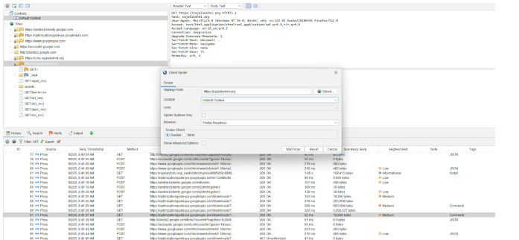

6. EXPECTED OUTPUT RESULT
Exported VAPT report detailing discovered application vulnerabilities, risk levels, parameter locations, and remediation recommendations.

7. VIVA VOICE QUESTIONS & ANSWERS
S.NO & VIVA QUESTION | TECHNICAL ANSWER
Q1. What is the difference between a vulnerability scanner and a manual penetration test? | Scanners check known signature patterns automatically. Manual pentests use logic to find complex business logic flaws and chain exploits.
Q2. What does ZAP's "Spider" function do before the active scan? | It crawls application links to map all URLs and form fields to build target attack surface.
Q3. Why can automated scanners produce false positives? | Scanners rely on generic response rules that can misinterpret custom application error pages as vulnerabilities.
Q4. Name two HTTP security headers a scanner checks for. | 1) X-Frame-Options (Clickjacking defense)  2) Strict-Transport-Security (HSTS)
Q5. Why is it important to run scans only against authorized/test targets? | Scanning generates high attack traffic and can cause Denial of Service or data corruption; unauthorized scanning is illegal.

